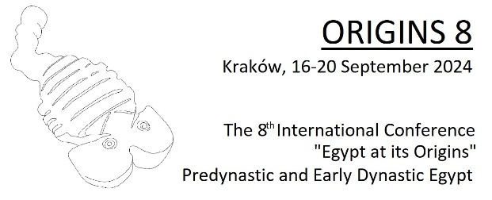

Abstract submission form

Select presentation type
First choice session: select session’s name
Second choice session: select session’s name
Author/s: enter author/s full name
Affiliation/s: enter your institution’s name/s

Enter the abstract title

Text: enter the abstract’s text: 500 words max, no references

